**Practical No:-** 07

**Roll No.:**15 **Batch-** A **Date of Performance:** 10/02/2024

1. **Write a program to create PDF document by using graphics concepts.**

<?php

$image=imagecreate(500,400);

$white=imagecolorallocate($image,255,255,255);

$black=imagecolorallocate($image,0,0,0);

imagestring($image,5,50,20,"Graphic Shapes",$black);

imageline($image,50,50,300,300,$black);

imagerectangle($image,150,150,350,350,$black);

imagefilledrectangle($image,50,250,150,350,$black);

imagedashedline($image,400,100,200,200,$black);

imagesetpixel($image,300,50,$black);

$values = array(

150, 50, // Point 1 (x, y)

55, 119, // Point 2 (x, y)

91, 231, // Point 3 (x, y)

209, 231, // Point 4 (x, y)

245, 119 // Point 5 (x, y)

);

imagearc($image, 250, 250, 150, 150, 25, 155, $black);

imagepolygon($image, $values, 5, $black);

header("Content-Type:image/png");

imagepng($image);

?>

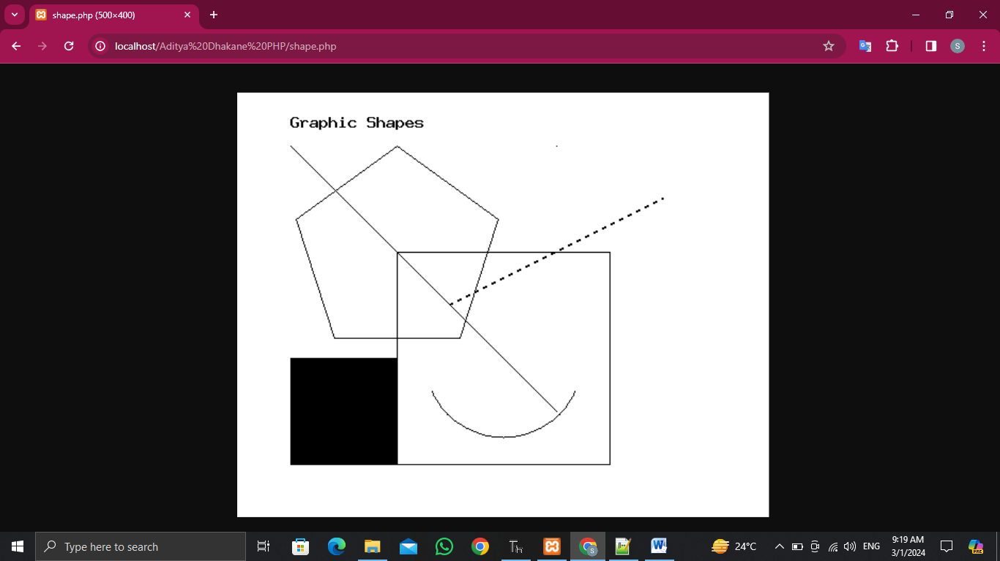



<?php

require('C:\xampp\fpdf186\fpdf.php');

$pdf = new FPDF();

$pdf->AddPage();

$pdf->SetFont('Arial', 'B', 20);

$pdf->Cell(40, 10, 'Hello PHP!');

$pdf->Ln(10);

$pdf->SetFont('Arial','', 12);

$pdf->MultiCell(0, 10, 'PHP, created by Rasmus Lerdorf in 1994, initially stood for Personal Home Page but evolved into PHP: Hypertext Preprocessor. It gained popularity for its ability to generate dynamic web content. Over the years, PHP has grown into one of the most widely used server-side scripting languages, powering a significant portion of the web, including platforms like WordPress and Facebook. Its open-source nature and continuous development have kept it relevant, with frequent updates enhancing performance, security, and functionality.');

$pdf->Output();

?>

